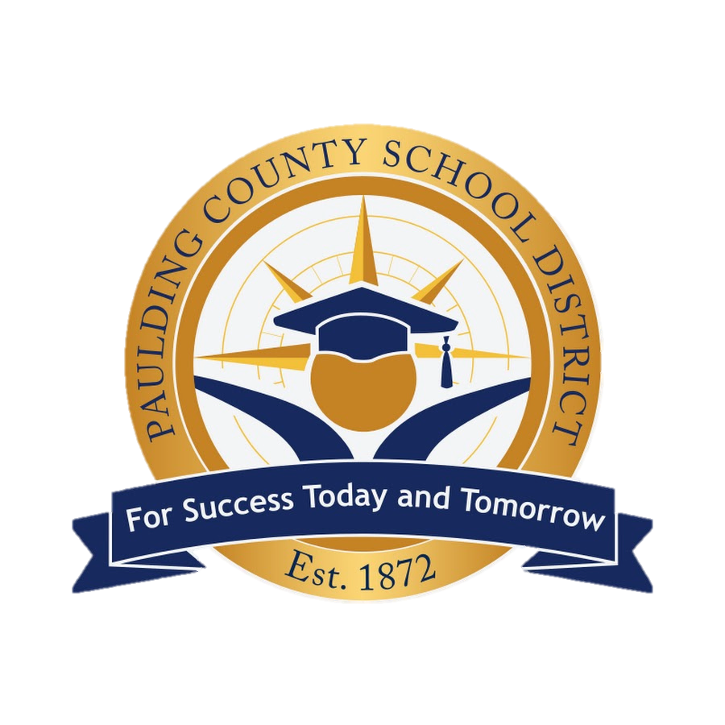

**Ragsdale Elementary School**

**Improvement at a Glance**

**Overview**

Understanding the mission, vision, and goals of a school is essential for stakeholders—such as students, parents, teachers, staff, and community members—because it provides a clear sense of purpose, direction, and shared values. The mission outlines the school's core purpose and what it aims to achieve daily; the vision presents a long-term aspiration for the future; and the goals identify specific targets to guide progress. When stakeholders are aligned with these elements, it fosters collaboration, accountability, and a unified effort toward student success and school improvement.

|  |  |
| --- | --- |
| **Mission** | **Vision** |
| ***Ragsdale’s Mission: Engage.  Inspire.  Prepare.*** | ***Ragsdale’s Vision: Prepare all students, with the shared responsibility of families and community members, to become successful citizens as they prepare for a challenging world.*** |
| **Goals** | |
| ***Accountability Goal 1:*** *On the Georgia Milestones Assessment (GMAs) we will increase our percentage of 3rd-5th grade students scoring2, 3, Accountability Goal 1: On the Georgia Milestones Assessment (GMAs) we will increase our percentage of 3rd-5th grade students scoring 2, 3,4 in ELA from spring 2025 baseline of  65% to 70% GMA administration and each grade level increasing 5% points.*  ***Accountability Goal 2:*** *On the Georgia Milestones Assessment (GMAs) we will increase our percentage of 3rd-5th grade students scoring 2, 3,4 in Math from spring 2025 baseline of 84% to 89% GMA administration and each grade level increasing 5% points.* | |

**Ragsdale Elementary Snapshot**

**Beliefs**

Is that we enrich the mind and frame the future of every student by supporting children with the shared responsibility of families and community members to become successful citizens as they prepare for a challenging world.

**Demographics**

Sara M. Ragsdale Elementary School, located at 528 Holly Springs Rd in Rockmart, Georgia, serves students in grades Pre-K through 5 within the Paulding County School District. The school has an enrollment of approximately 630 students. The student body is made up: Caucasian or white 69%, black or African American: 13.2%, Hispanic: 9.8%, Multiracial: 7.0%, Asian: 0.7%, Native American: 0%, Pacific Islander: 0%. Approximately 66.19% of students at Ragsdale Elementary qualify for free or reduced-price lunch. Academically, Ragsdale Elementary is in the top 50% of Georgia schools for overall test scores and has been deemed one of the safest schools in Paulding County.

Explain the school’s demographics.

**Honors/Awards/Certifications**

2022-2023 PBIS Distinguished School Award

2021-2022 Literacy Leader and recipient of the L4GA Community Literacy Grant by the GaDOE

2018-2019 5 STAR School Climate Rating from the Georgia Department of Education

2018-2019 PBIS Emerging School Award

No Place for HATE distinction for completing a yar of anti-bias and anti-bullying

2017 and 2016 Cenergistic outstanding energy conservation Certificate of Achievement

2016 EPA’s ENERGY STAR award